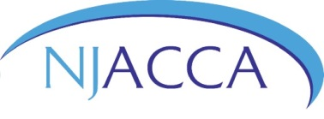
New Jersey Air Conditioning Contractors Association
N E W J E R S E Y S T A T E A S S O C I A T I O N
PO Box 7 | Mullica Hill, NJ 08062 | (877) 818-0699 | njacca.org

(Month) (Day) (Year)

The Honorable (First name) (Last name),

Trenton, New Jersey, 08625

RE: Please oppose S3071/A3666 (Madden/DeAngelo)

Dear (Assembly Member/Senator) (Last name):

My name is (your first and last name) and I am an HVACR business owner, as well as a resident, of your district. I am writing to respectfully request that you oppose S3071/A3666, which requires public works contractors' workers to participate in, or have completed a registered apprenticeship program. If passed, the measure will significantly impact HVACR businesses operating in New Jersey, who would become subject to the bill’s onerous apprenticeship requirements.

New Jersey’s current apprenticeship infrastructure does not have the capacity or ability to meet the requirements of the measure. Additionally, as written:
- All workers subject to the Public Works Contractor Registration Act, would have to participate in, or have completed a registered apprenticeship program, putting a burden on many of our families; and
- Contractors who have performed HVACR work for a number of years, without completing an apprenticeship, would be subject to these new overburdening requirements.
In closing, this bill will put an undue burden on my business, which is already licensed, and my employees who will be required to add additional training beyond what we have already provided. I am asking you to please help our industry and community by opposing this legislation.

Sincerely,

(Be sure to include your name and address on both your letter and envelope.)

